GIT COMMAND LINE
Prepared by: Nisarg Rajput
Date: 09/10/2019
Version: 0.1
Document Category: draft

Add your Git username and set your email
It is important to configure your Git username and email address, since every Git commit will use this information to identify you as the author.
In your bash, type the following command to add your username:
$git config --global user.name "YOUR_USERNAME"
$ git config --global user.name
→ Then verify that you have the correct username
$ git config --global user.email "your_email_address@example.com"
$ git config --global user.email
→ To verify that you entered your email correctly, type:
$ git config --global --list
Check your information To view the information that you entered, along with other global options, type:

Git working flow diagram
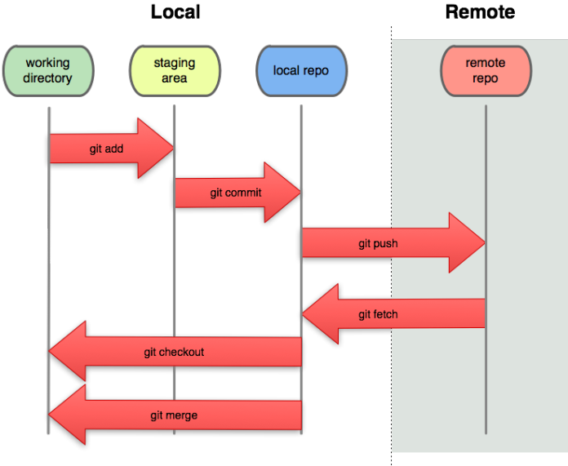

The image shows how git works and there are basically three stage:
- Working Directory: When you make changes to files in your checked out branch you make changes to the working directory.
- Staging Area: To stage a file is simply to prepare it finely for a commit.
Git, with its index allows you to commit only certain parts of the changes you've done since the last commit.
- Commit: Now your commit is your project with the first feature done, and ready to go to repository

The basic Git workflow goes something like this:
1] You modify files in your working tree.
2] You selectively stage just those changes you want to be part of your next commit, which adds only those changes to the staging area.
3] You do a commit, which takes the files as they are in the staging area and stores that snapshot permanently to your Git directory.

Scenario 1: Initialize a local repository from existing code
You want to track your code base from git and yu have it ready on the local machine but it is not shared with anyone else so follow the below steps to start tracking your project.

$ git init [project-name]
→ Creates a new local repository with the specified name
→ .git directory is created to for tracking the project.
$ rm -rf .git
→ .git will be removed and you are stooped tracking the project.
$ git status
→ Lists all new or modified files from working directory to be committed.
$ git reset
→ resets all files from the staging area.
$ git commit -m “Commit message”
→ Records file snapshots permanently in version history.

Scenario 2: Common Workflow
1.Create a branch
$ git clone [url] [path]
→ Downloads a project and its entire version history.
$ git branch [branch name]
→ Creates a new local branch from master with the specified name
$ git branch
→ List out all local branch
$ git branch -a
→ List out all branch from local as well as remote
$ git checkout [branch name]
→ switch/checkout the branch from specified name.
*Note : Develop thr feature in the Local branch first ensure its fine and then commit on local repo and then remote repository.*
$ git add -A
→ Add the changes in to staging area.[-A is for all the changes and files]
$ git diff
→ It will list out the Difference what you have made it to file.
$ git commit -m “Commit message”
→ it will commit all the staged changes to the local repo.
$ git pull
→ pull the changes from the master/branch before pushing it to the remote.

$ git push -u origin [branch name]
→ push the changes to the remote branch.
*Note : Up to this your changes will be uploaded to remote branch successfully.*

2] Merge the branch to you master.
$ git checkout master
→ switch/checkout the master
$ git pull
→ pull the changes from the master/branch before pushing it to the remote.
$ git branch --merged
→ List out all the merged branch on the master
$ git merge [branch name]
→ Merge the branch locally in the master.
$ git push -u origin master
→Push merged master to the remote
$ git branch --merged
→ List out all the merged branch on the master
*Note : Up to this your changes will be uploaded to remote master successfully and everyone can take those changes from the remote*
3] Delete the branch
$ git branch -d [Branch name]
→ delete the specified branch from the local.
$ git branch -a
→ display local and remote branches
*Note : This command will show that local branch is gone and remote is still present*

$ git push origin –delete [branch name]
→ delete branch from the remote.
$ git branch -a
→ display local and remote branches
*Note : This command will show that both local and remote is gone now *

Fixing mistakes
1] Mannage a single file to remove the unwanted content
$ git diff
→ display local differences (if some thing unusual found in a file)
$ git checkout <file>
→changes will be removed and updated the last checkout file content.

2] Manage a commit message if it is missed interpreted or wrong
$ git commit –amend -m “Message”
→change the commit message if previously it is wrong
*Note : This will create the new hash for the same commit i.e. Number of commits are not increased from this*

3] Manage a commit file if it is missed in a single commit
I.e If the some file is not committed in desired commit
$ git commit –amend
→will add the file in same commit with changed hash

$ git log –stat
→This command will show the descriptive status of the last commit.
4] Cherry picking
→If mistakenly you have developed a feature on master instead of branch.
$ git log
→ copy the hash which has the changes to cherry -pick
$ git checkout [desired branch to add feature that feature]
$ git cherry-pick [copied hash]
$ git status
$ git log

*Note : the above steps will cherry -pick the changes to your checked-out branch *
Now you can commit your changes to remote, merged it to master and delete as common workflow.

5] Reseting the master
$ git checkout master
$ git log
→ copy the hash below the cherry -picked hash
$ git reset –soft <Copied hash>
$ git status
→ --soft and --mixed leave your files untouched.
$ git reset –hard <Copied hash>
→ This resets everything - it resets HEAD back to another commit, resets the index to match it, and resets the working directory to match it as well.

